Software Engineering PR280

Nick Leslie

Iteration 2

## Plan/Goal

To complete the second problem in Appendix Two, using VueJS.

Add Bootstrap to website to ensure HTML doesn’t get cluttered

## Design Level Class Diagram

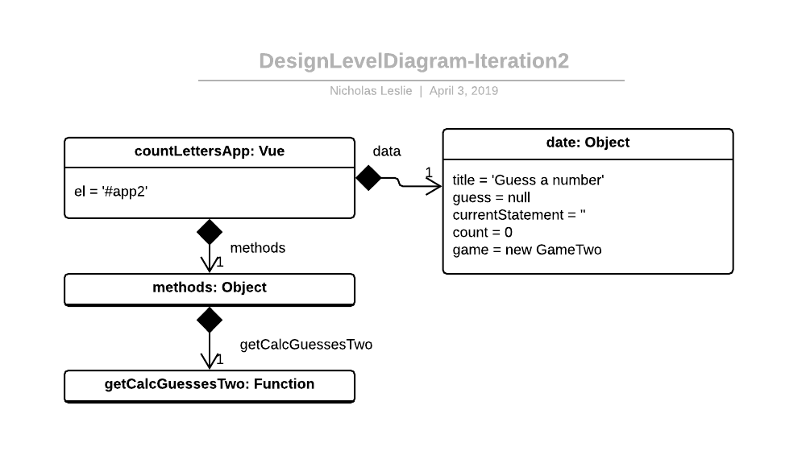

## Plan for how the program feature of an iteration you are working will work

Wireframe:

<https://wireframe.cc/ArHyh9>